Sprint Review and Retrospective
Jeremiah (Jay) Case
SNHU
CS-250
Professor Krupa
02/19/2026

Sprint Review and Retrospective
During the SNHU Travel project, our team piloted a Scrum-Agile approach as part of ChadaTech’s transition from waterfall development. Throughout the course, I rotated through roles such as Product Owner, Developer, Tester, and Scrum Master. This experience gave me a clear understanding of how Agile works in practice and how each role contributes to project success.
Because the SNHU Travel project required collaboration, frequent feedback, and adjustments to requirements, it was a strong example of how Scrum can improve both teamwork and software quality (Schwaber & Sutherland, 2020).

Applying Scrum Roles
One of the biggest lessons I learned during the SNHU Travel project was how important each Scrum role is (Schwaber & Sutherland, 2020).
When I took on the Product Owner role, I focused on prioritizing user stories that added the most value to the SNHU Travel app. For example, we prioritized features like browsing travel packages and booking reservations before adding smaller improvements. This helped the team stay focused on what mattered most to stakeholders.
As Scrum Master, I organized sprint meetings, encouraged team participation, and helped remove blockers. For instance, when there was confusion about how the travel package filtering feature should work, I helped facilitate a discussion so developers could continue working without delays.
When working as a Developer, I saw how important clear requirements were. Developers depended on the Product Owner’s backlog and Scrum Master’s guidance to stay on track. As shown in Figure 1, the product backlog helped prioritize high value user stories.
As a Tester, I reviewed the functionality of booking confirmations and travel package displays. Testing during each sprint helped identify issues early.
Overall, seeing the project from multiple roles helped me understand how Scrum teams rely on shared responsibility and communication, which research shows is important for distributed Agile teams (Moe et al., 2021).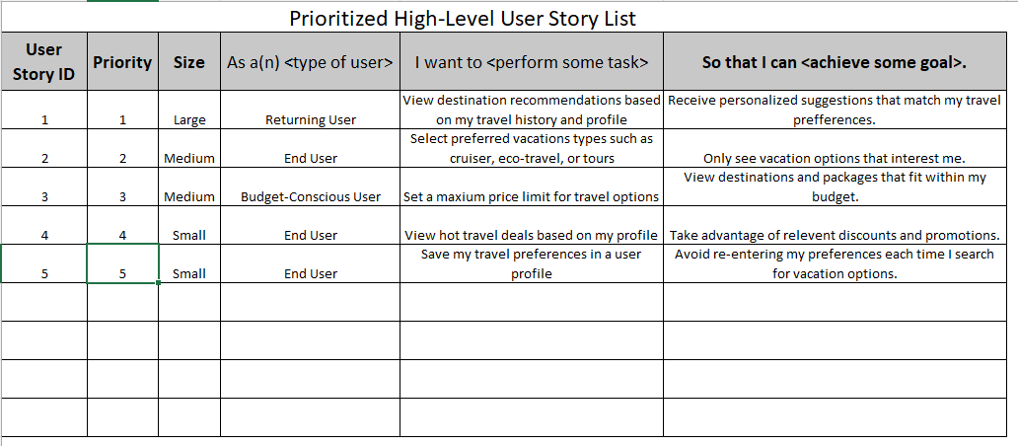
Figure 1
Example of SNHU Travel product backlog showing prioritized user stories.

Completing User Stories with Agile
Agile made completing user stories easier because the work was broken into small, manageable tasks (Rigby et al., 2020).
Some examples of user stories from the SNHU Travel project included:
- As a traveler, I want to browse travel packages so I can compare destinations.
- As a traveler, I want to filter by price so I can stay within budget.
- As a traveler, I want to book a trip so I can confirm my reservation.
During sprint planning, we selected a small number of stories that could realistically be completed. Daily scrums helped us track progress, and sprint reviews gave us feedback.
Because of this process, we were able to deliver working features each sprint instead of waiting until the end. This made the project feel more organized and less overwhelming. Figure 2 shows an example of a user story used in sprint planning.
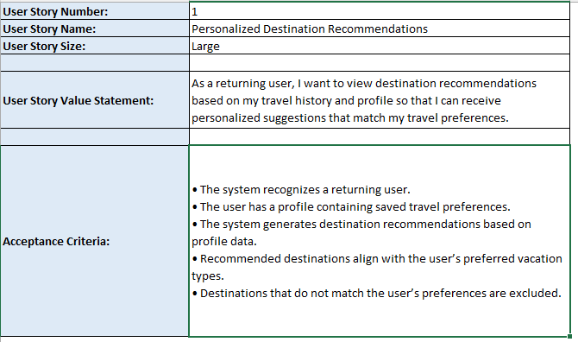
Figure 2
Sample user story created for the SNHU Travel project.

Handling Interruptions
One thing that stood out to me during the SNHU Travel project was how Agile helped when requirements changed.
At one point, stakeholder feedback required us to adjust how travel packages were displayed. Instead of starting over, we added new user stories to the backlog and adjusted our sprint plan.
This flexibility made it easier to adapt without losing work. If we had used a waterfall model, we would have had to redesign large parts of the application, which would have taken more time. Agile allowed us to stay productive even when the project changed direction (Rigby et al., 2020).

Communication
Communication was one of the most important parts of the SNHU Travel project (Miranda et al., 2025). We used daily scrums to share updates, identify blockers, and coordinate tasks. Sprint reviews allowed us to demonstrate progress and get feedback, while retrospectives helped us reflect on improvements.

Here is an example of a standup update I might have shared:
Daily Scrum Update – SNHU Travel
Yesterday: Finished testing travel package search
Today: Begin testing booking confirmation
Blockers: Need clarification on error message formatting
This type of communication was effective because it was short, clear, and focused. It helped the team stay informed and encouraged collaboration.
Another example of communication was during sprint reviews, where the team demonstrated the updated travel package interface and collected stakeholder feedback. This allowed us to clarify requirements early and prevented rework later in development. These meetings encouraged collaboration because every team member had a chance to ask questions and suggest improvements, which is a key factor in Agile team effectiveness (Moe et al., 2021). Figure 3 shows an email example of team communication during a sprint.
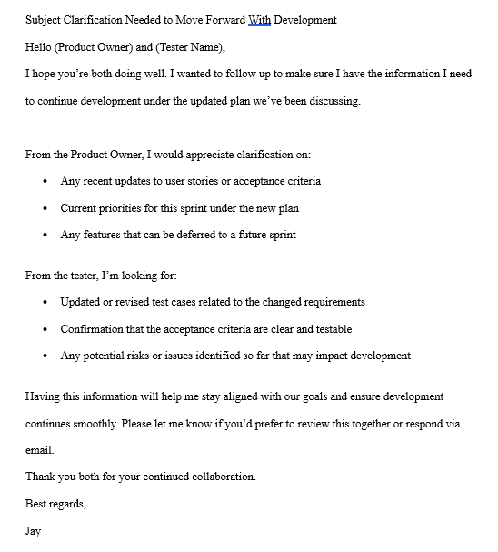
Figure 3
Example communication between team members during the SNHU Travel sprint.
Organizational Tools
During the SNHU Travel project, organizational tools were closely tied to Scrum events. The product backlog was used during sprint planning to select user stories, sprint boards tracked progress during daily scrums, sprint reviews demonstrated completed features to stakeholders, and retrospectives helped us identify improvements for the next sprint. These tools made it easier to stay organized, communicate priorities, and keep the project moving forward, which aligns with Agile tool recommendations for backlog and sprint tracking (Microsoft, n.d.). As shown in Figure 4, the sprint task board helped track progress and ensured that tasks were completed within each sprint.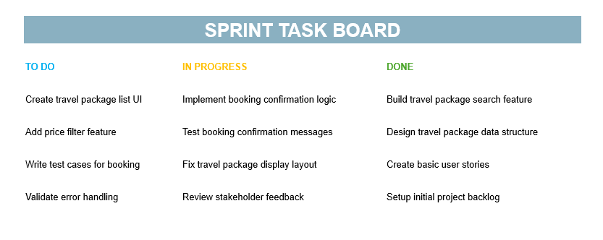
Figure 4
Example sprint task board used to organize the SNHU Travel project

Evaluating the Agile Process
Pros of Scrum-Agile
From my experience, Agile provided several benefits:
- Flexibility when requirements change
- Faster feedback from stakeholders
- Improved teamwork and communication
- Continuous testing and improvement
Cons
There were also challenges:
- Requires strong communication skills
- Hard to estimate timelines accurately
- Team members must understand Scrum roles

Agile approaches allow organizations to adapt to changing requirements and scale development more effectively (Rigby et al., 2020).

Was Agile the Best Approach?
Although Agile worked well for SNHU Travel, a waterfall approach could be useful for projects with fixed requirements and strict regulatory constraints. For example, if the travel system had required detailed security certification before development, waterfall planning might have been more appropriate. This comparison helped me understand when each methodology should be used.

Conclusion
The SNHU Travel project showed me how effective Scrum-Agile can be for software development. By rotating through roles, completing user stories in sprints, adapting to changes, and communicating regularly, our team was able to deliver a successful application.
Based on this experience, I believe ChadaTech should continue moving toward Agile development, while also providing training and support to help teams adjust to the new process (Schwaber & Sutherland, 2020). This project also strengthened my confidence in using Agile methodologies in future software development roles.

References
Miranda, D., Noël, R., Godoy, J., Escobedo, C., Cechinel, C., & Muñoz, R. (2025). Quantitative analysis of communication dynamics in agile software teams through multimodal analytics. Scientific Reports, 15(1), Article 9898. https://doi.org/10.1038/s41598-025-91328-x
Moe, N. B., Šmite, D., Ågerfalk, P. J., & Jørgensen, M. (2021). Understanding the dynamics in distributed agile teams: A mixed-methods study. Information and Software Technology, 130, 106453. https://doi.org/10.1016/j.infsof.2020.106453
Rigby, D. K., Sutherland, J., & Noble, A. (2020). Agile at scale. Harvard Business Review, 98(3), 88–96. https://hbr.org/2018/05/agile-at-scale
Schwaber, K., & Sutherland, J. (2020). The Scrum guide: The definitive guide to Scrum. Scrum.org. https://scrumguides.org
Microsoft. (n.d.). What is Azure Boards? Microsoft Learn. https://learn.microsoft.com/en-us/azure/devops/boards/get-started/what-is-azure-boards

